[your-url-goes-right-here.com](http://www.your-url-goes-here.com)

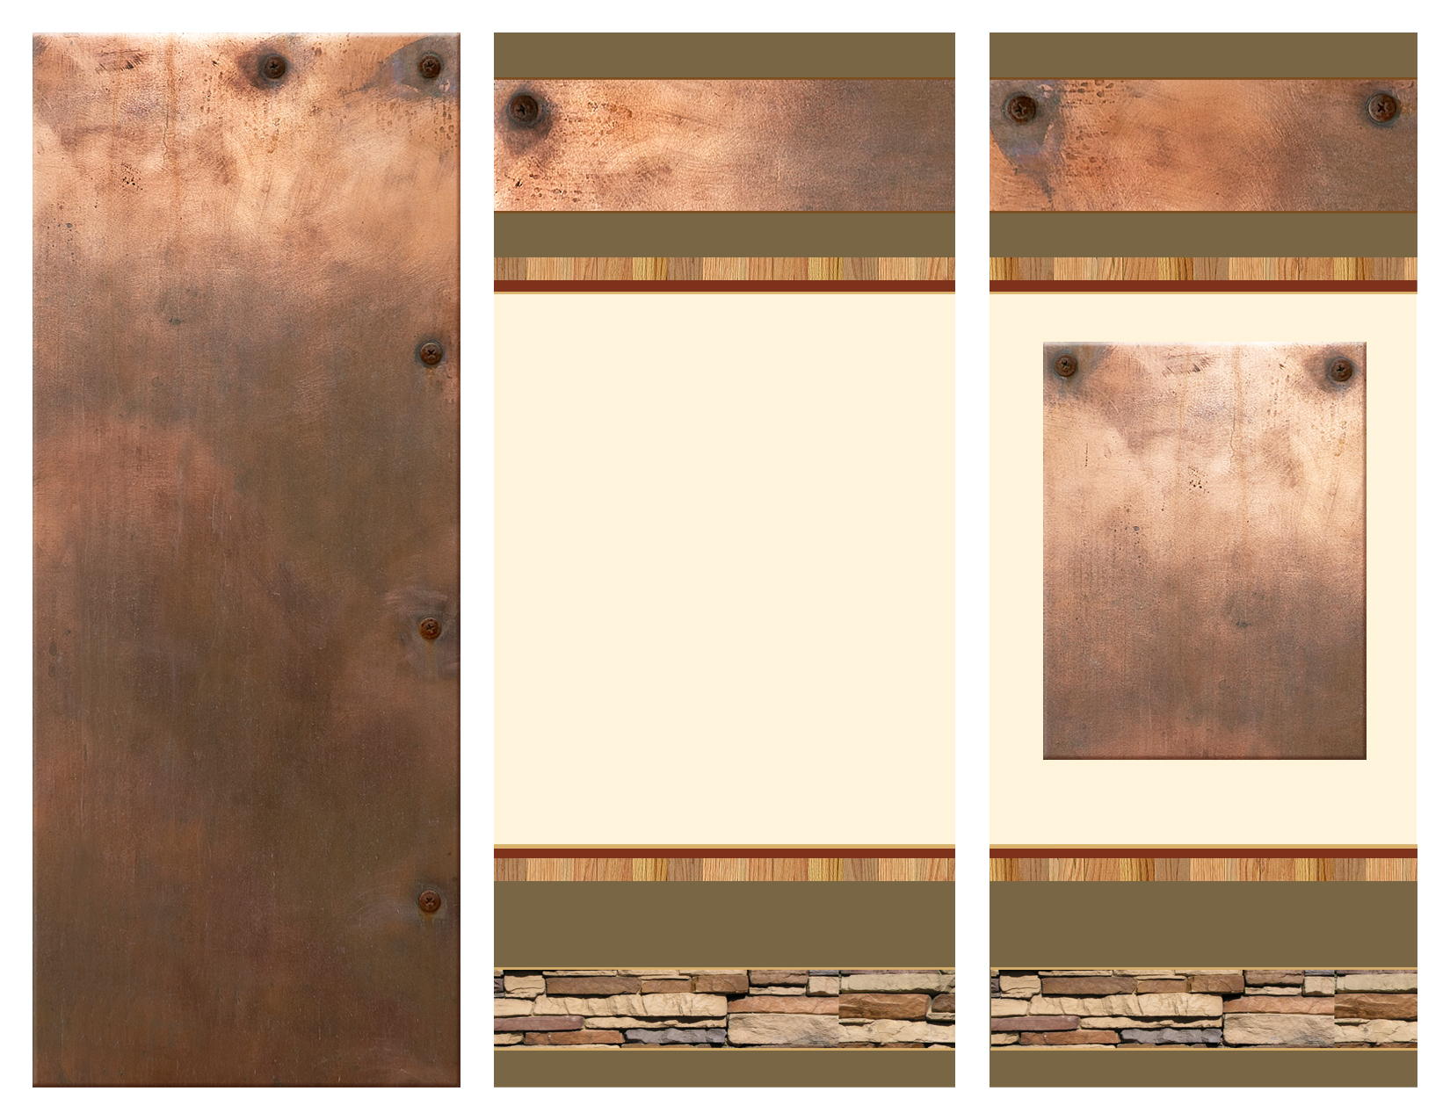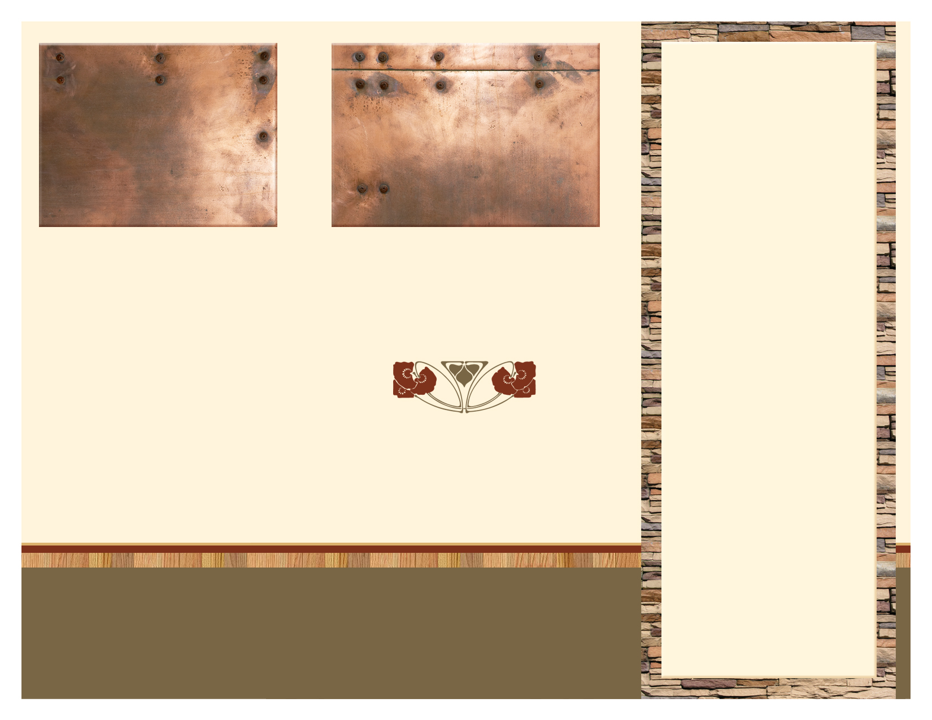

*Helping to see that students and young adults who have sustained a Traumatic Brain Injury succeed at their dreams in both school and life*

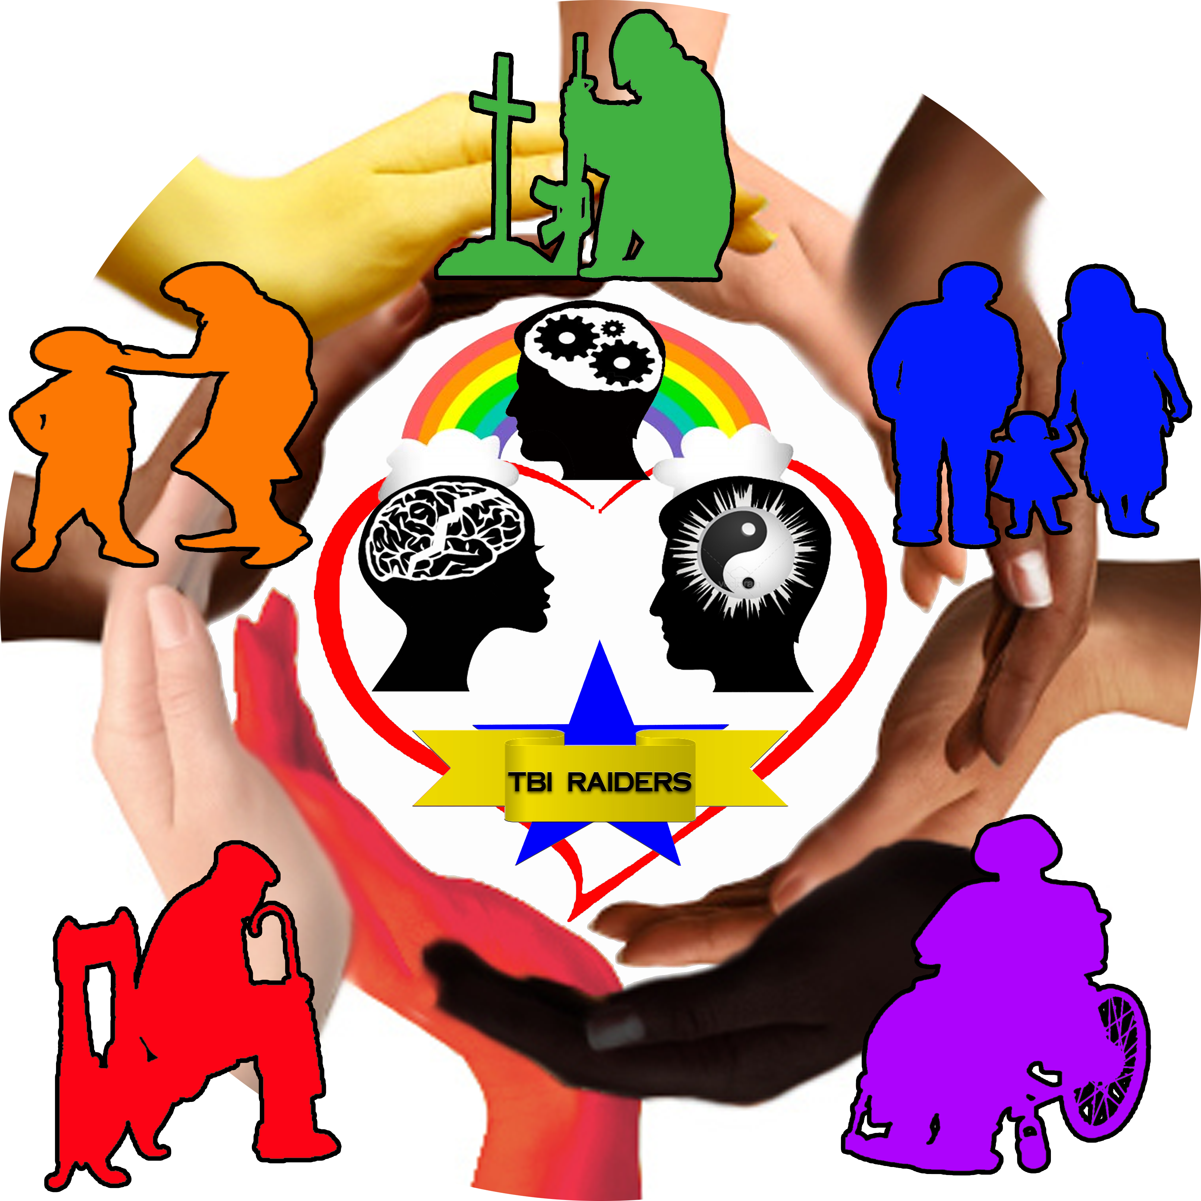

ph 405-698-2403 | fx 440-550-6315 | Txt Us @ 405-714-4497

TBI Raiders

Projects

TBI Raiders

Email: [tbiraiders@gmail.com](mailto:tbiraiders@gmail.com)

Website: <http://raidersmembers.yolasite.com>

Video

Volunteers saying the statistics and realities of Traumatic Brain Injury

Opportunities would have with TBI Raiders

Internships with TBI Raiders via Service Learning Volunteer Center at Oklahoma State University

Committees with TBI Raiders

Interviews about Responsibilities for Positions Internships Committees

Member & Volunteer Benefits

Meetings

“Never say never even when you think you’ve taken your last step.”

Executive Director

Allie Murie

Creating an Online Jeopardy Game

This would be a game with questions that had to do with Traumatic Brain Injury…statistics, facts, organizations, support groups, side effects, etc.

Poster Board

What Leadership Means to Me

What Volunteering Means to Me

• Become a national non-profit

• Start building a scholarship for TBI survivors (starting with Oklahoma) from the profit made from the online stores for TBI Raiders and Members of TBI Raiders

What Director Murie Would Like to See Happen with TBI Raiders:

• Student Organizations form on college campuses that would include also survivors that lived out in the community

• Chapters become created

Determination gets you where you want to be

I’ve always been a stubborn and hard headed type of person. If you told me the statistics of what I more than likely I would never be able to do again, I was and am still out to prove you wrong. When I got out of the hospital I knew I always wanted to help others with Traumatic Brain Injury. But it was when I was attending Rose State College; I gained a bigger sense of what I needed to do. My fave thing to do was to nag my dad (36 yr vet of the army) about how high I scored on the ASVAB test. Took me close to 2 yrs to learn but found out I scored in the top 1%. I know I will never be able to serve in the Armed Forces but still want to help Americans. So I started with one thing which led to another and that got me to where I am. I am extremely grateful also that the state and congressional leaders for Oklahoma that would provide help when I was looking for information on TBI, legislation, or referrals to those who could help me more. Now its just my job to show others how I did everything and how they can do it too.

Why these projects are needed

*“In the nearly 16 years I have lived with a Left-Right Traumatic Brain Injury, I am completely astounded at how little is known about Traumatic Brain Injury, that there are more misconceptions that I can count about the disability, and what little is being done. Given that no two TBI’s are alike, I still want a chance to help other survivors. I was broadsided at 60mph on the driver’s side, had the driver’s door slammed half way in the middle of the driver’s wheel, bottom left three ribs broken, and brain slammed against both sides of the skull at 60mph. So I’m living proof a severe TBI survivors can recover decently enough.”*

Creator/Founder

Alicia (Allie) Murie

These projects are to help increase the awareness and education on Traumatic Brain Injury

**These projects are to be completed in a 5 year time span**

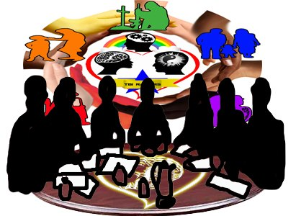

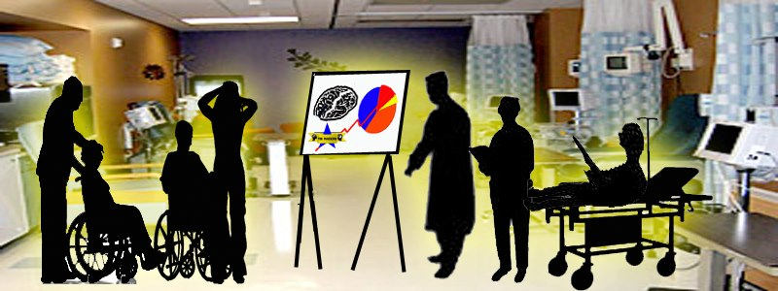here.

“Tell me I can’t do something and I’m going to find a way to prove you wrong.”

Allie Murie