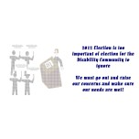

This is to start to bridge together a community for those living with and without disabilities. TBI is a disability that can affect anyone and everyone…look at the causes…multiple incidenes can result in a TBI from a car accident to a fall to an IED. While there is a ton of research being done on Traumatic Brain Injury survivors, it does not bring to light the capabilities of those living with a TBI. TBI Raiders can and will. The Executive Director, Alicia (Allie) Murie, has lived with a Left-Right Traumatic Brain Injury since November 22, 1997. She is wanting to help show others that anything is possible! You might have to adjust your plans but it important to NEVER EVEN WHEN

YOU THINK YOU’VE TAKEN YOUR LAST STEP! A motto Allie keeps close to her heart.

**We are here to support Traumatic Brain Injury survivors and their families…to show them there is a way to strive for success despite having the odds stacked against you**

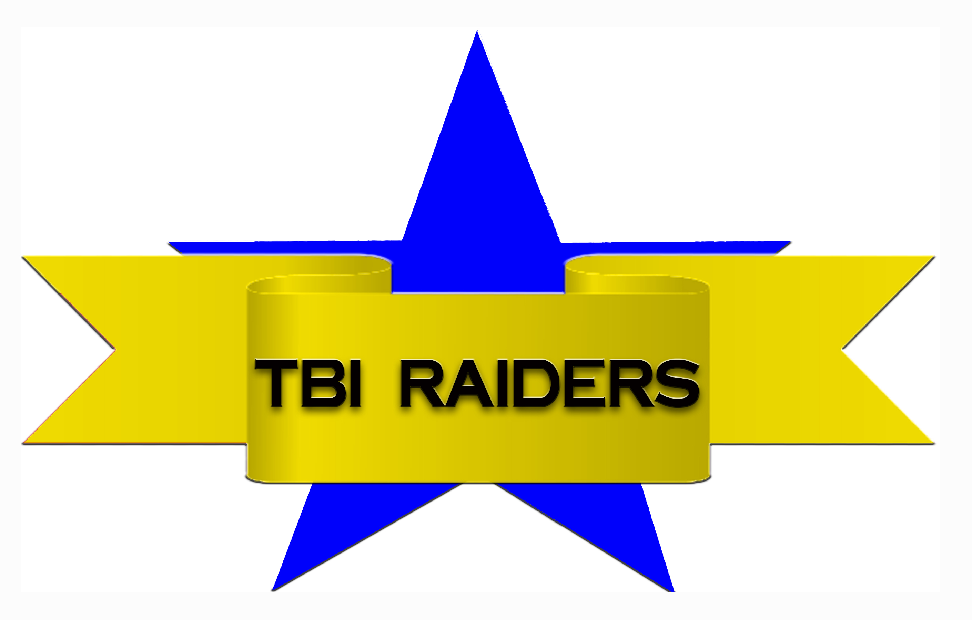

C/O Allie Murie, Executive Director

3700 W 19th Ave. Apt M-1

Stillwater, OK 74074

Voicemail:405-698-2403

Text Message: 405-714-4497

[tbiraiders@gmail.com](mailto:tbiraiders@gmail.com)

<http://tbiraiders.yolasite.com>

# TBI Raiders

Helping to see that students succeed at their dreams in both school and life

## TBI Raiders Programs

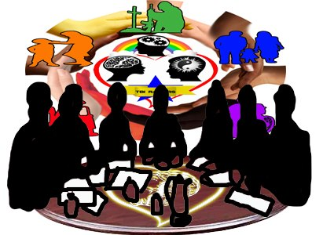

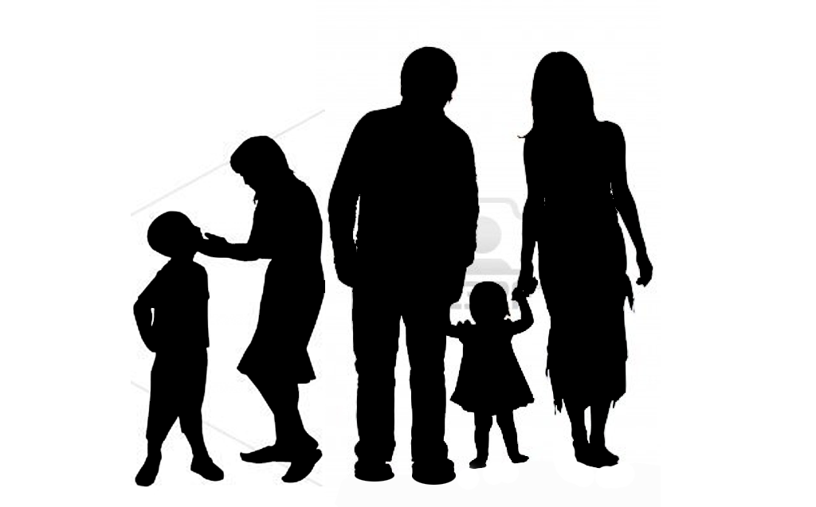

### Creating a Stronger Community…

Is working on building student organizations on college campuses to create a stronger voice and more opportunities for TBI survivors, get involved and help make it a reality!

Hello,

When I created and started out TBI Raiders in January of 2002. It started out as only an online club. I dreamt of it becoming so much more than what I was wanting but never thought it would be possible for that to happen. But as time passed and I grew and gained more knowledge/connections, I thought I should try to make it happen.

Now with the 12 yr anniversary being next year, it really seems like everything I ever wanted to do to help other Traumatic Brain Injury (TBI) has a chance of becoming a reality, BUT for this to happen, I need your help!

### Message from the Executive Director, Alicia Murie

Caption describing picture or graphic.

#### TBI’s Corner

To provide a source explaining traumatic brain injury and how it affects every group of individuals, teens, and adults for school. It will further provide answers and resources to those who want to learn more about the disability and find organizations and businesses that can better assist those affected by TBI. Its primary focus is to emphasize an individuals’ re-entry to school.

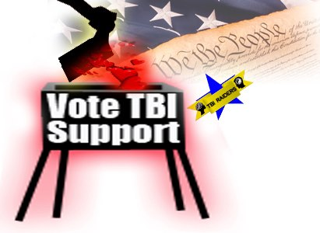

#### Members of TBI Raiders

This is a place in which the volunteers with and without a TBI can come relax, build an online resume, and highlight and empower the volunteer service and the community work in which individuals who have a traumatic brain injury engage actively. Its primary focus is to emphasize an individuals’ re-entry to the workforce.

**Survived to Vote**

Started in 2005 with the purpose to get issues important to the disability community out in not just the time of election but out to those who are presently in office working to represent everyone. It is about ensuring elected officials show equal representation for not only societal norms but also those who have disabilities.

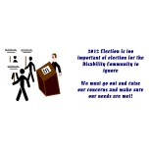

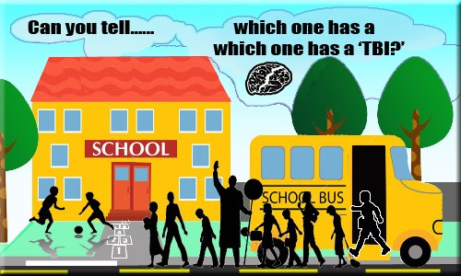

# TBI Raiders