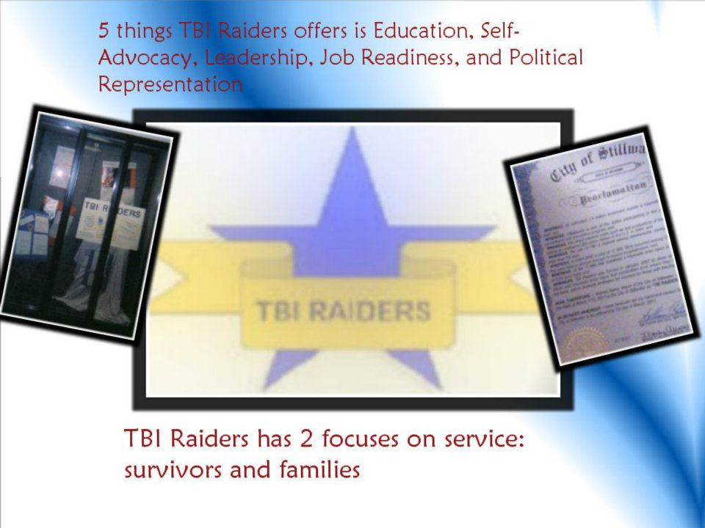

TBI Raiders Yearly Events:
Volunteer Training
Raiders Explosion
Raiders Experience

An opportunity to educate everyone about the REALITIES of Traumatic Brain Injury survivors and the CAPABILITIES of those living with the disability, just as anyone can be affected by a Traumatic Brain Injury, the potential outcomes of those living with the disability should not be set by limits. Yes the goals and dreams that are set by those who have sustained a Traumatic Brain Injury may need to be adjusted or changed but that doesn’t mean that once you sustain a TBI, everything is hopeless. No two TBI’s are alike.

If you had a friend who had been in an automobile accident where they not only had been broadsided at 60 miles per hour but the driver’s door had been slammed half way in the middle of the driver’s wheel, bottom left three ribs broken, and the brain would slam against both sides of their skull at 60 miles per hour, do you think they would have survived?
Well that is what happened to TBI Raiders Executive Director, Allie Murie when she was only 16 years old. At the time she loved helping others and planned on becoming a professional ballerina. She may never be able to dance professionally but she can still dance and more importantly she never has had to give up her love for helping others and in the process has learned how to become more of a leader that creates change around her.

Member Training

This takes place every August. This is to not only educate the members about Traumatic Brain Injury, but to…
- Also show the capabilities and potentialities of survivors
- Teach the members about the opportunities that exist within the organization
- Get started on creating an online resume for the members
- Let them know of the events that they can help with and the committees they can join
- Let them know of the partnership TBI Raiders has with the Service Learning Volunteer Center
This is to help the members get started on creating a better future for themselves to go on to bigger and better things once they finish with their schooling.

Raiders Explosion

This takes place every November the week prior to Thanksgiving. The reason for this is Director Murie’s near fatal accident happened November 22, 1997. It not only serves as a remberence for her and reminds her of why she does what she does but she wants others to think of the decisions they make behind the wheel especially around the holidays. The holidays, like any other day of the year, should be celebrated and spent with those we care about instead of wondering if someone we care about is going to live or going to die.
Day one of the event will focus on disabilities in general since once you sustain a TBI you may acquire multiple disabilities. So it is important to educate on all disabilities. Day two will tie everything together with focus on Traumatic Brain Injury.

Raiders Experience

This is to be in March. This is to celebrate the capabilities of survivors but to also educate others of the true realities to try to limit the misconceptions which may form. The first day will seek to bring more awareness on Post-Traumatic Stress Disorder.

