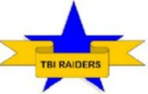C:\STOCKLAYOUTS\CURRENT PROJECTS\FN99804-PL\FN99804-IMG02.emf

Outcomes

**For Traumatic Brain Injury Survivors**

1. Increased Knowledge of Traumatic Brain Injury
2. More Advocacy
3. Benefits
   1. Online Resume
   2. Opportunity to increase what they know aka job skills

**For Non-Disabled Students**

1. Learn more about disabilities
2. Make a difference in their community and/or on their school’s campus
3. Benefits
   1. Online Resume
   2. Opportunity to increase what they know aka job skills

**For Students with Disabilities**

1. Learn how to do more advocating
2. Discover what and how they can do to help those with their disability
3. Benefits
   1. Online Resume
   2. Opportunity to increase what they know aka job skills